Reference date: 31 March 2021

Difference in mean and median hourly rate of pay
 | Difference in the mean hourly pay | Difference in the median hourly pay
Pay gap. % difference male to female | 20% | 49%

Difference in mean and median bonus pay
 | Difference in the mean bonus pay | Difference in the median bonus pay
Pay gap. % difference male to female | - | -

Proportion of male and female employees who were paid bonus pay
 | Proportion receiving a bonus
Male employees (% paid a bonus compared to all male employees) | -
Female employees (% paid a bonus compared to all female employees) | -

Proportion of male and female employees according to quartile pay bands
 | Quartile 1.  Lower | Quartile 2.  Lower middle | Quartile 3.  Upper middle | Quartile 4.  Upper
Male (% males to all employees in each quartile) | 5% | 7% | 10% | 13%
Female (% females to all employees in each quartile) | 95% | 93% | 90% | 87%

Supporting statement
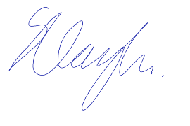
I confirm that the information published here is accurate.
Signature: |  | Date: | 29/03/2022
Status/position: | Director of Finance

Optional supporting narrative
On 31 March 2021 the trust employed 44 men (25 of whom are teachers) and 462 females (143 are teachers).

